November 2018
Dear RTS Member/Supporter

Invitation to attend the biggest media awards event in the North East

The Royal Television Society North East and The Border Centre is pleased to announce that tickets can be booked for its Annual Awards to be held on Saturday 23rd February 2019 at The Hilton Newcastle Gateshead. Please note that the maximum table size is 12.

Up to 500 programme makers, commissioners, supporters and executives will attend the event alongside a host of presenters and celebrities. The ceremony and dinner will celebrate all aspects of media production in the region – from television shows to on-line programmes and video games.

If you would like to be part of this prestigious event, a booking form is attached.

We have negotiated a special rate at the Hilton Newcastle Gateshead which is £99 per night single or double occupancy including breakfast. There are a number of rooms available but must be booked by 24th January 2019 to get the special rate. The reservation can be cancelled up to midnight the day prior to arriving without any charge. Booking via the website you can book at this price but you need to guarantee with credit card with payment on departure. Please ring Hilton Reservations on 0191 490 9707. Quote ARTSA and the rooms are subject to availability. Please use the link to the Hilton website in my email.

If you would like to book your tickets, please return the forms by MONDAY 4TH FEBRUARY 2019 at the latest to avoid disappointment. Tickets for the Awards ceremony and Dinner are £65 plus VAT (£78). We have a special price for NEW members who joined the RTS from February 2018. The price is £55.00 plus VAT (£66.00) but proof of new membership must be supplied at the time of booking.

I look forward to seeing you.

With best wishes
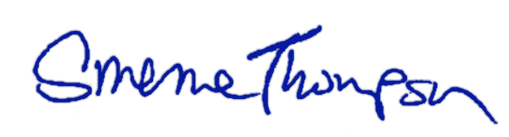
Graeme Thompson
Chair, RTS North East and the Border Centre Annual Awards

Correspondence details:
 Jill Hodgson, RTS North East & The Borders Awards, 7 Westfield Grove, Gosforth, Newcastle upon Tyne NE3 4YA
 0191 285 7699 or 07846 226631
  jill.hodgson1.rts@btinternet.com

