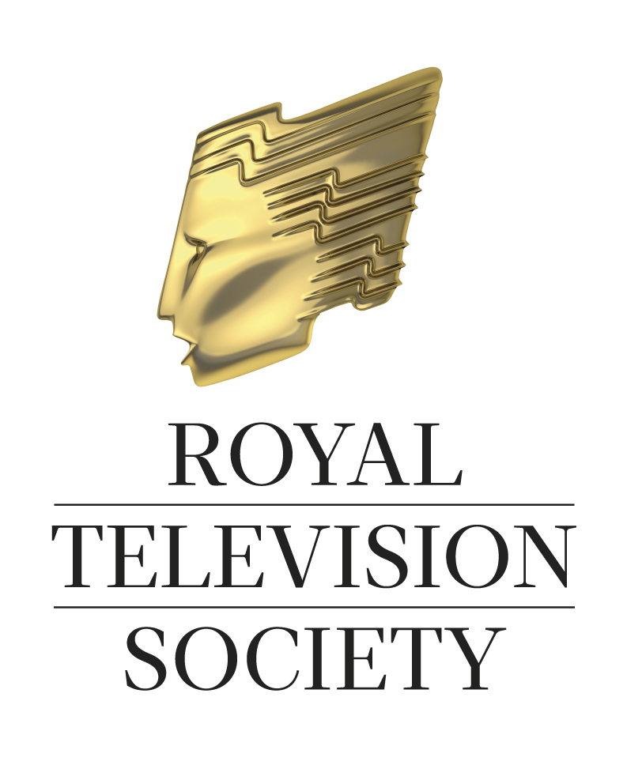
Jury Citation: RTS Wales Centre Student Television Awards, 2014

Introduction

The RTS Wales Centre Jury panel consisted of the following members:

Hywel Wiliam, Jury Chairman, Administrator, RTS Wales Centre
Chris Buxton, Lecturer, Senior Research Associate, UWTSD
Llion Iwan, Content Commissioner, Factual and Documentary Programmes, S4C
Zoe Rushton, Producer, BBC Cymru Wales
Mike Talbot, Series Editor, Wales This Week, ITV Cymru Wales
Cath Tudor, Director, TV Teams

In all, 14 entries were received covering four of the competition categories (3 fewer than in 2013). Following the merger in 2013 of the University of Glamorgan and Newport University to form the University of South Wales, almost all the entries this year (as last year) came from this new institution, with only one other entry received from Bangor University.

This year for the first time, the RTS has introduced a new Open category for entries that are a maximum of 3 minutes in length which can be on any subject matter. Although no entries were received in this category, the Jury decided that one entry, in the Entertainment category, deserved to receive an Open award. The Jury decided that it was not entirely clear how this entry should have been classified, but its high quality justified an award in the Open category.

Taking account of this decision the final breakdown of the entries were as follows:

Animation: 4 entries
Entertainment: 1 entry
Factual: 5 entries
Drama: 3 entries
Open: 1 entry (transferred from the Entertainment category)

Although they were very disappointed that a greater range of universities in Wales did not submit entries, particularly as they understood that, due to financial constraints, entries would otherwise have been received from a third institution. However, the Jury Members were greatly impressed with the very high standard evident in the programmes and short animations submitted which clearly demonstrated a mastery of technical and production techniques. They were also impressed by the number of entries which had received significant amounts of crowd sourced funding.

The RTS Awards are for student television productions that show outstanding visual and aural creativity, a mastery of craft skill, innovation and initiative. Productions should also take account of the requirements of broadcast television and the Jury Members based their decisions mainly on these criteria.

Factual
There were five entries in this category including one Welsh language entry, Canfod Cariad, submitted by Bangor University. All the other entries were submitted by the University of South Wales. Powder Rooms of the Female Kind provided an insight into the reasons women wear make-up through the use of direct close-up head and shoulder shots which generally worked well. However, the slightly varying backgrounds reduced the visual impact to some degree and the Jury felt it would have benefitted from some tighter editing. The Jury commended the ambition of Men in Stripes, which was shot on location in Finland, but it was also rather long and lacked clarity, particularly in the rather confusing sequences that mixed animation with live action. Porters offered a moving and insightful account of a group of workers who rarely feature in any documentaries about hospital life, but whose stories in this case were very compelling. The programme was very well shot and edited, with excellently framed interview sequences, although the generally very effective slow motion sequences were occasionally over used. The Jury members were also very impressed by the degree of access obtained by the programme makers and the extensive research and planning that would have been required for the production. One Member added that the programme was virtually ready for broadcast.

Winner: Porters : James Dougan, Max Cutting, Dan Ridgeon
Nominated entries: Men in Stripes, Powder Rooms of the Female Kind

Entertainment
The Jury decided that of the two entries received in this category, Vice Versa - Creation should be re-allocated to the Open category due to its factual content, which in their view did not sit comfortably in the Entertainment genre. However, the Jury were unanimous that the remaining entry, The Bullet Catch, fully deserved to be awarded as a winner in this category. The was a charming story about an incompetent magician and his talented assistant. It featured a strong main cast, some very amusing attention to detail and an engaging production style.

Winner: The Bullet Catch : Catherine Attwood, Yuan Huang, Xanthe Young & Team

Drama
There were three entries in this category, all submitted by the University of South Wales.
X Row portrayed life in a dystopian future in which the death penalty had been re-introduced. However, although the original idea was innovative, the Jury felt its central premise was not entirely plausible and some technical aspects, for example lighting, needed some attention in places. Papa' Portable Crematorium was also highly original and ambitious in its depiction of a documentary maker's attempts to manipulate a story for his own glory. However, the Jury felt the drama's narrative was difficult to follow at times and some of the performances were unconvincing. A Mermaid's Tail presented a very moving story based around child abuse. It was beautifully shot and edited with some well crafted camera work which presented effective and compelling transitions between reality and a make-believe world of the main character's own creation.

Winner: A Mermaid's Tail : Luke Tucker, Lorna Truman, George Dallimore, Athena O'Connor-Lindsey
Nominated Entries: X Row, Papa's Portable Crematorium

Animation
All four entries in this category came from the University of South Wales. Traditional model based animation was the central feature of Cut from The Same Cloth, which was a very accomplished piece that told the story of an old tailor and his apprentice working on Savile Row. It featured beautiful, smooth animation with engaging characters with an old fashioned feel which perfectly matched its subject matter. The Awoken made ambitious use of CGI animation combined with live action to depict an invasion of monsters onto the streets of Cardiff. However, although it featured some amusing sequences, it felt incomplete with the lighting created for the CGI monsters not entirely matching the video based backgrounds. Training Video made clever use of narration and line drawing animation to tell an amusing story, but the Jury felt that both its narrative flow and its humorous content were uneven, requiring further editing and development.

Winner: Cut From the Same Cloth : James Carlisle
Nominated entries: The Awoken, Training Video

Open Award

Although no entries were originally received in this category, the Jury felt strongly that
Vice Versa - Creation deserved to be awarded. It was an original and highly accomplished production with a simple but effective format, which featured two protagonists who provided very different perspectives on life.

Winner: Vice Versa - Creation : Natasha Hawthornthwaite, Rhodri Carter, Daniel Ridgeon

NOTE TO EDITORS
All of this year's winning entries were submitted by the University of South Wales.
The winners were announced at the Zoom Cymru International Youth Film Festival closing ceremony, which was held on 27 March 2015.

The first prize winner in each category will also be submitted for judging at the UK final of the RTS Student Television Awards, to be held in London during May 2015.

RTS Wales Centre
March 2015

